1-Test Techniques Overview
Chapter 4 part 1 EP _ BVA - start at 1:11
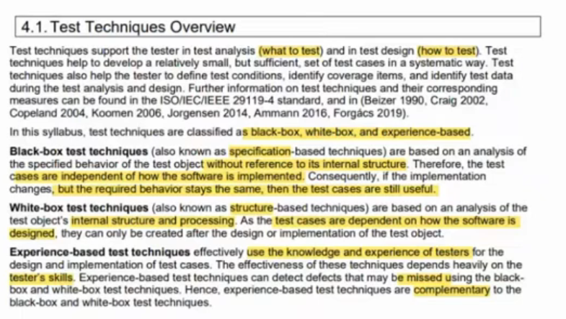

2-Black-Box Test Techniques
Chapter 4 part 1 EP _ BVA - start at 4:09
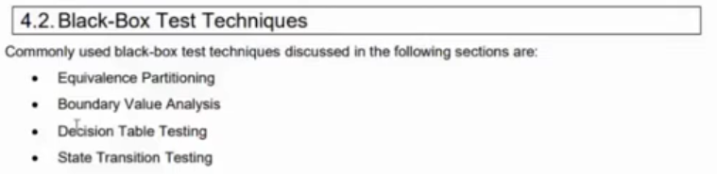

2.1-Equivalence Partitioning

Slide
Chapter 4 part 1 EP _ BVA - start at 7:53
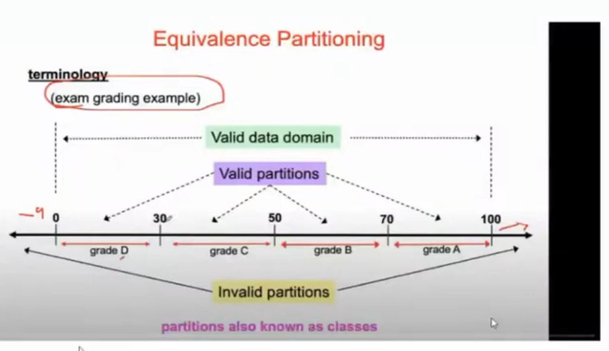

Details
Chapter 4 part 1 EP _ BVA - start at 13:05
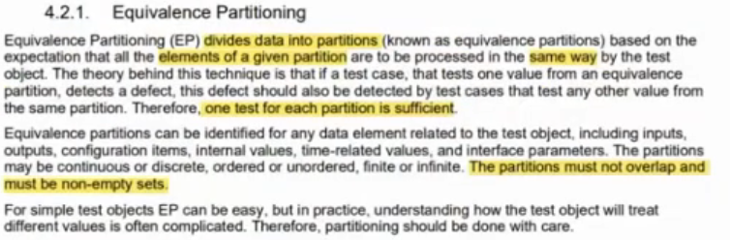
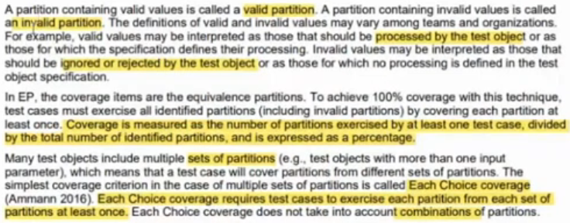

Questions
Chapter 4 part 1 EP _ BVA - start at 19:38
Q1
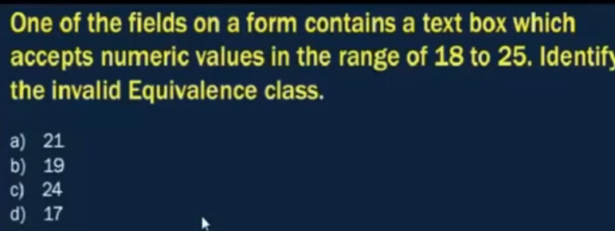
Q1 - Answer
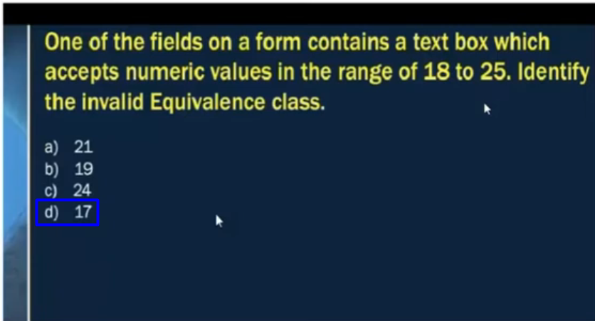
Q2
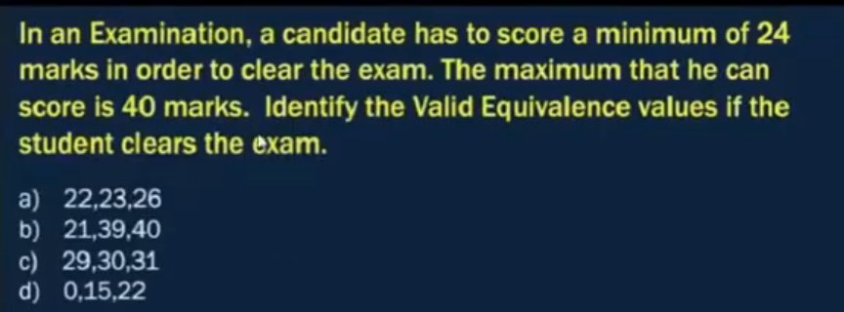
Q2 – Answer
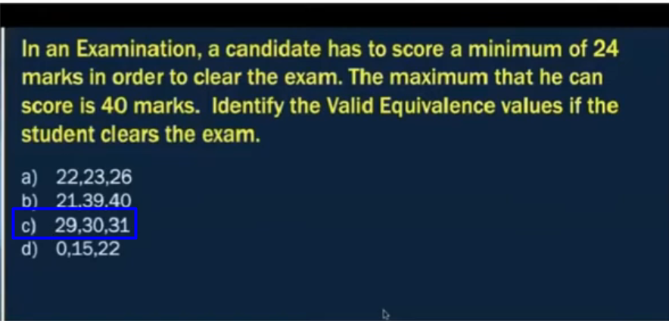
Q3
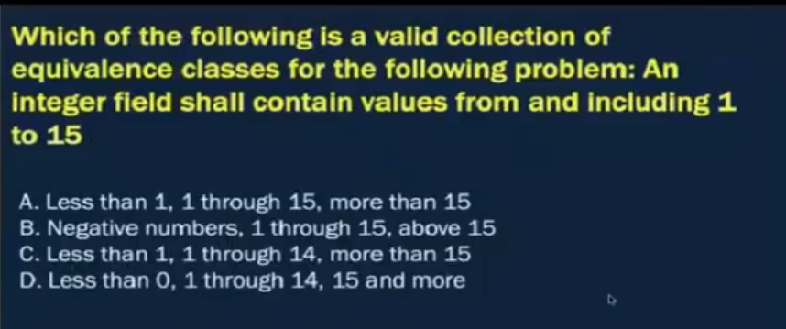

Q3 – Answer
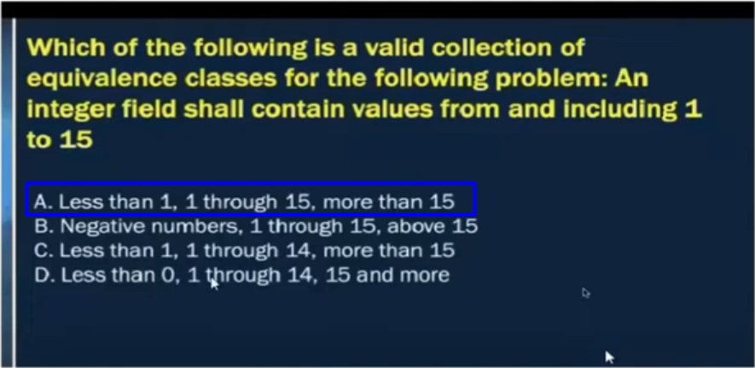
Q4
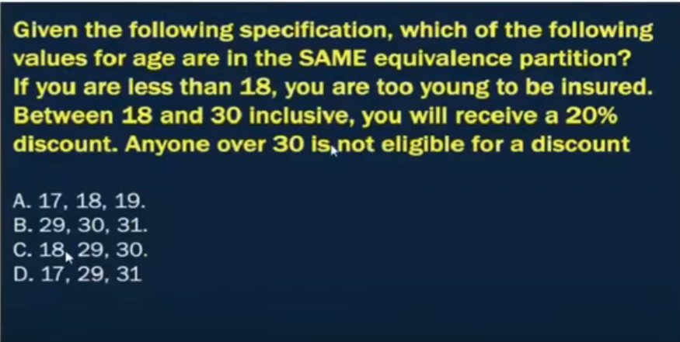

Q4 – Answer
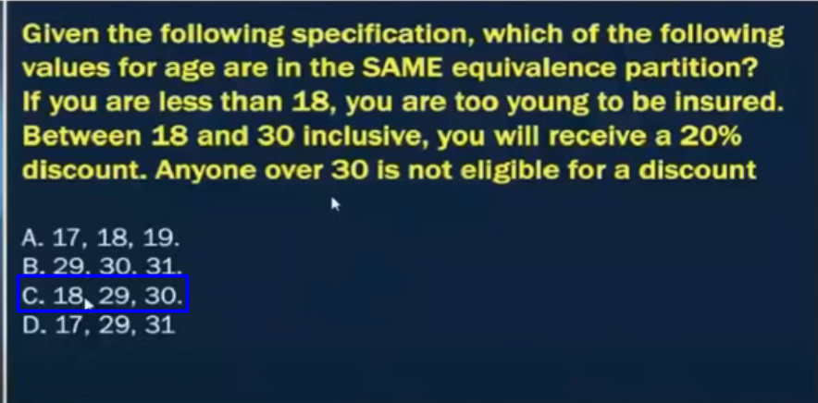
Q5
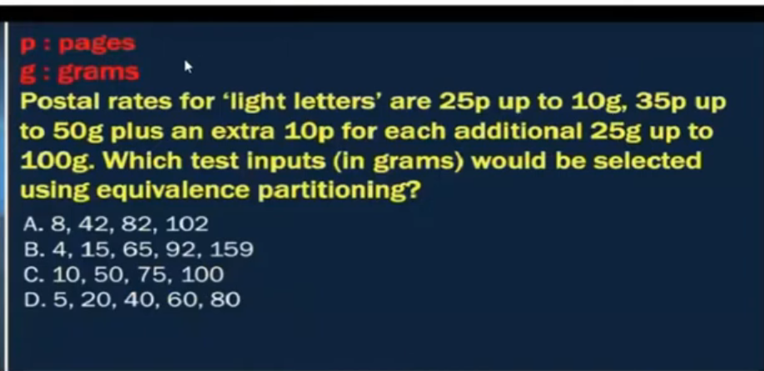

# Source: AI Source: Provided by: [Data Path: Persons Table -> ID Column: 1, Name_En Column: Motasem Essam] -> From: [Chatgpt (GPT‑5 Mini)] on [8/15/2025]
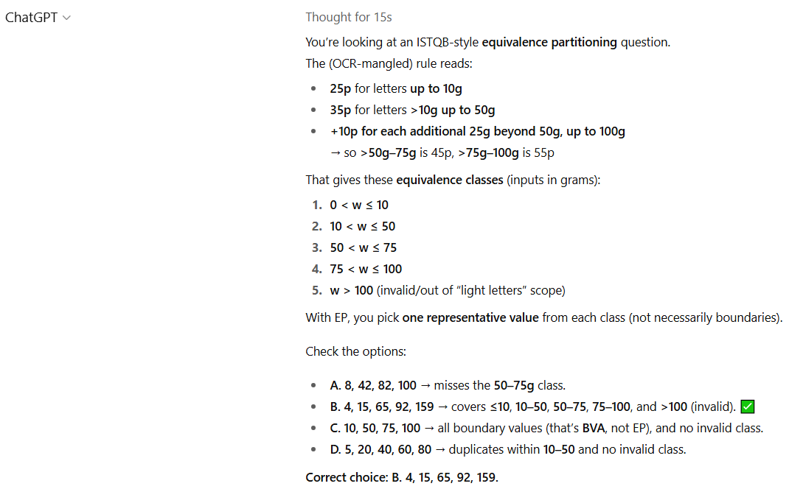

Q5 – Answer
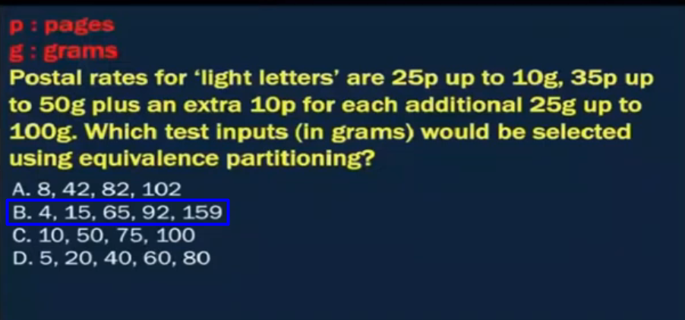
Q6
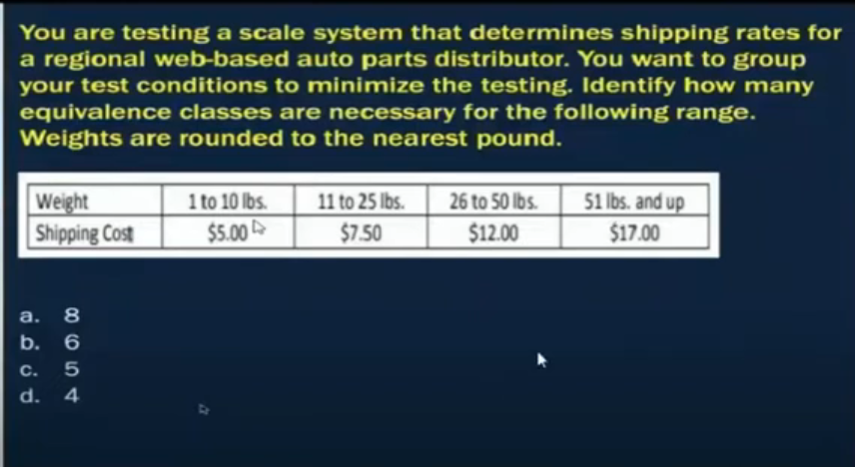
# Source: AI Source: Provided by: [Data Path: Persons Table -> ID Column: 1, Name_En Column: Motasem Essam] -> From: [Chatgpt (GPT‑5 Mini)] on [8/15/2025]
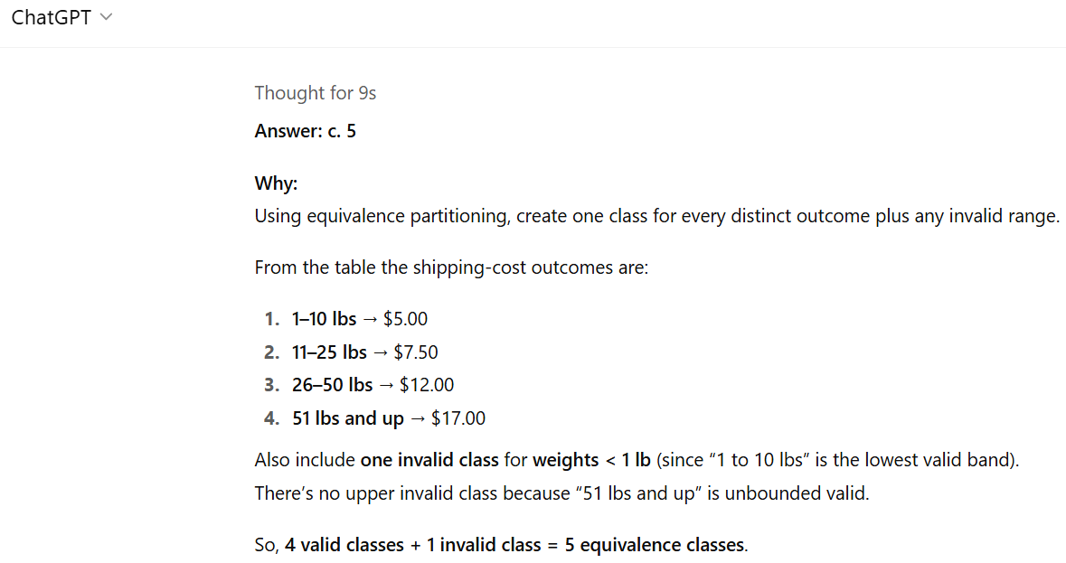
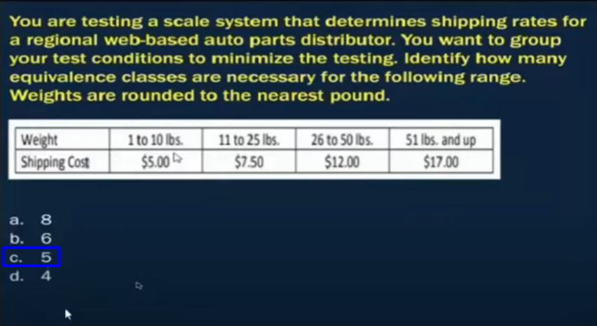

2.2-Boundary Value Analysis

Slide
Chapter 4 part 1 EP _ BVA - start at 44:49
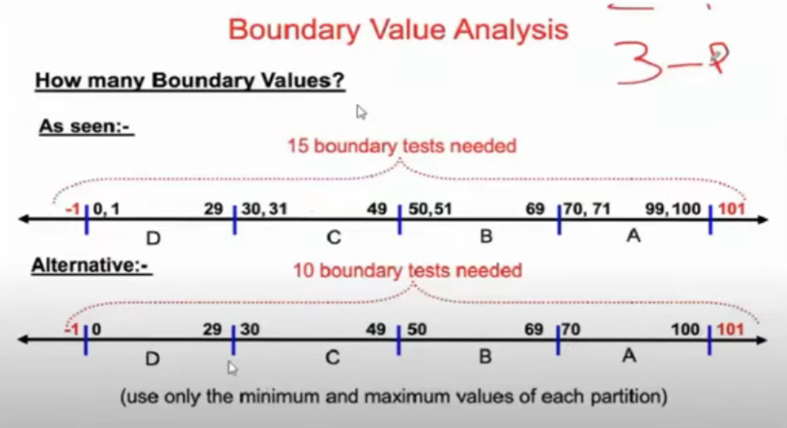

Details
Chapter 4 part 1 EP _ BVA - start at 50:43
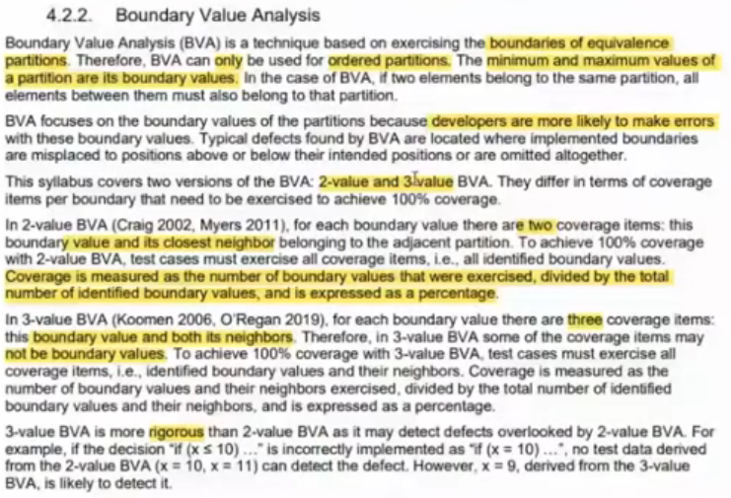

Questions
Chapter 4 part 1 EP _ BVA - start at 50:53
Q1
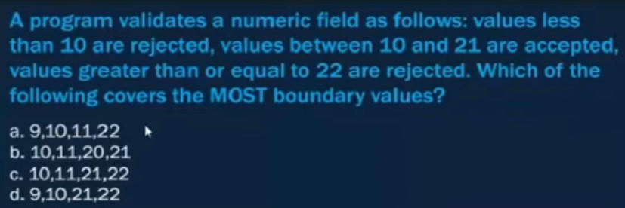
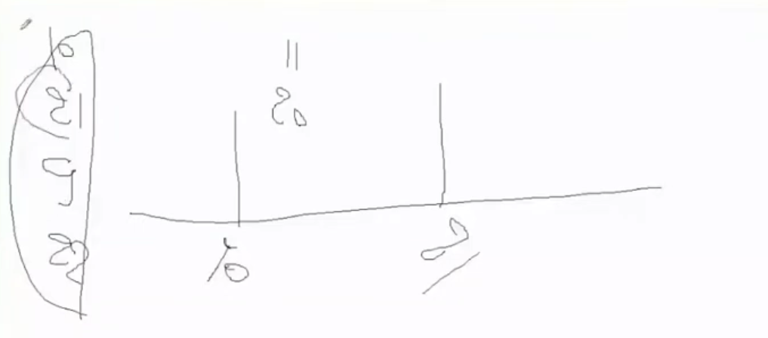
Q1 - Answer
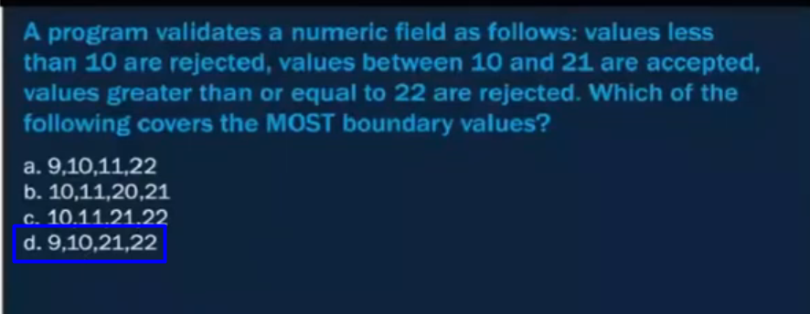
Q2
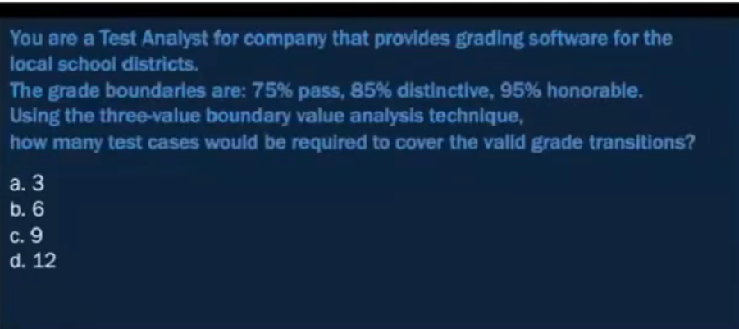
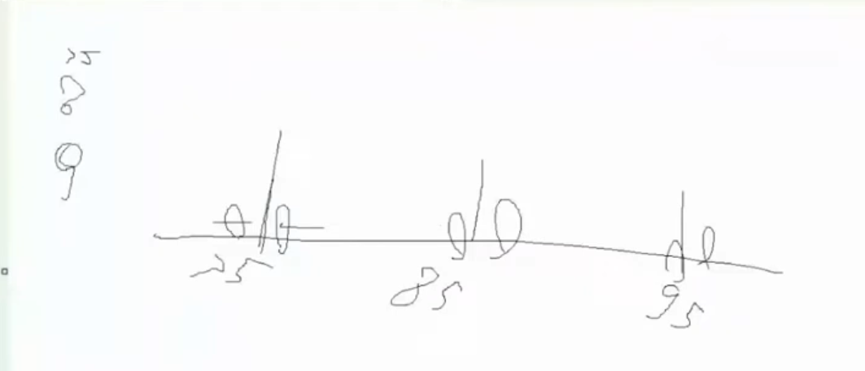
Q2 - Answer
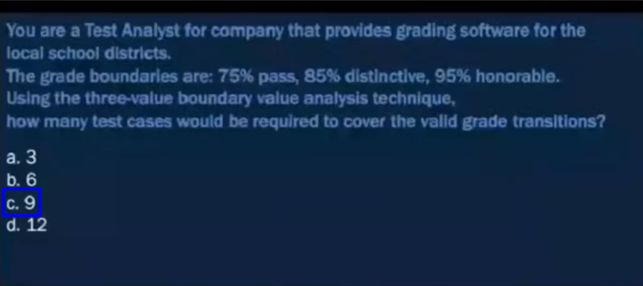
Q3
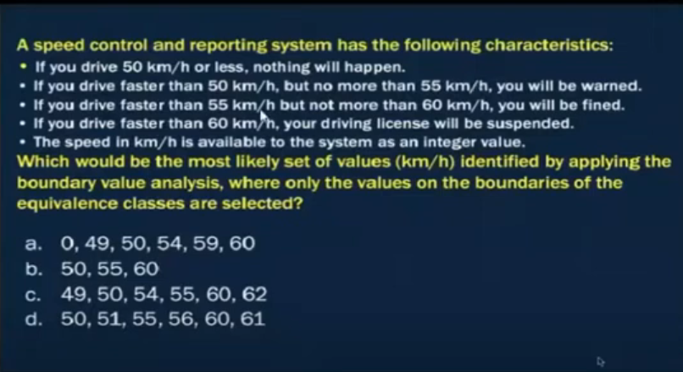
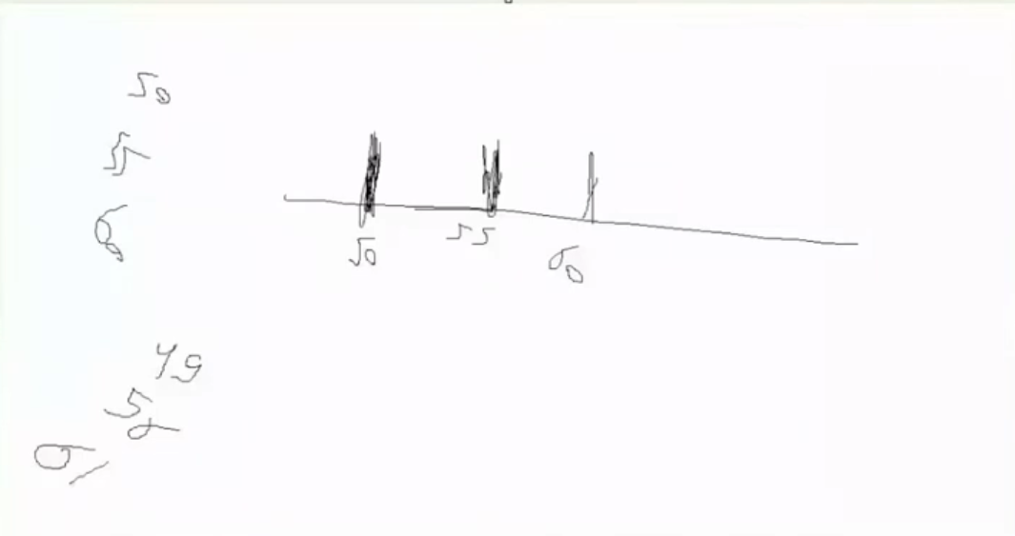
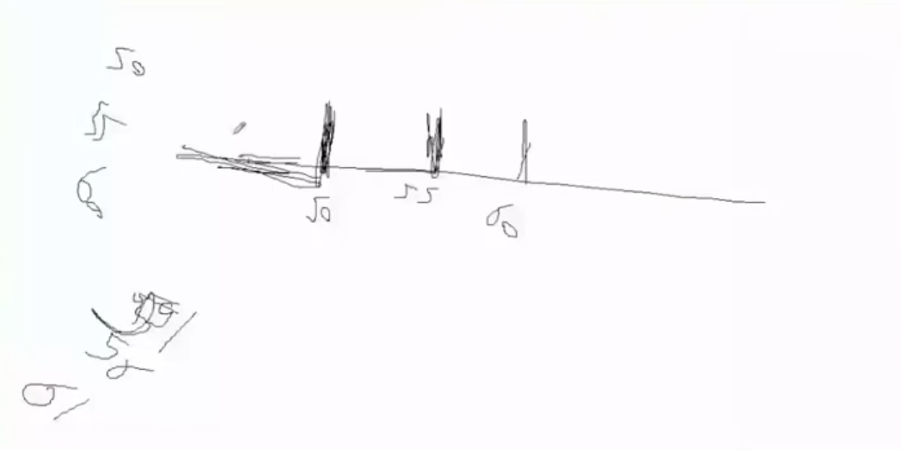
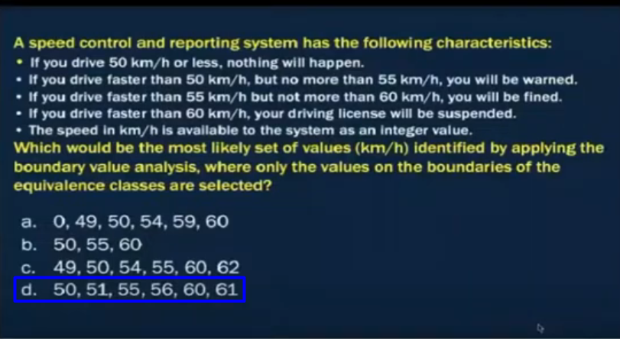

2.3-State Transition Testing

Details part 1
Chapter 4 part 2 state _ Decision - start at 0:25
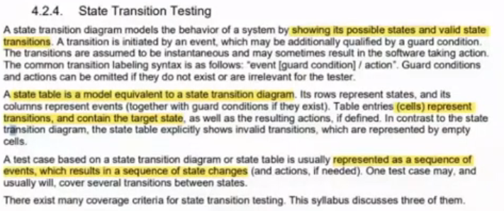

Slide
Chapter 4 part 2 state _ Decision - start at 1:53
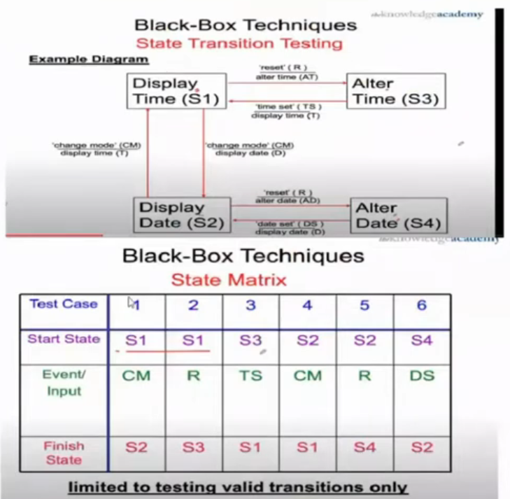

Questions
Chapter 4 part 2 state _ Decision - start at 10:39

Q1
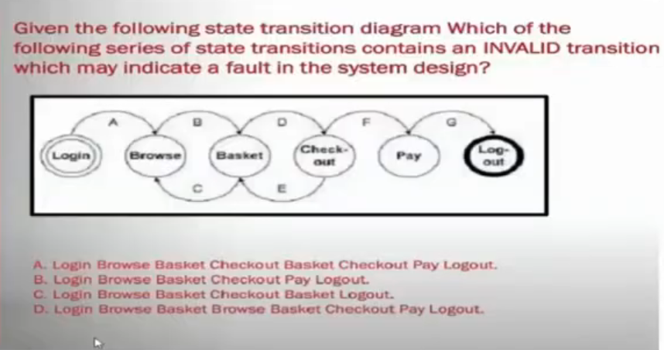
Q1 - Answer
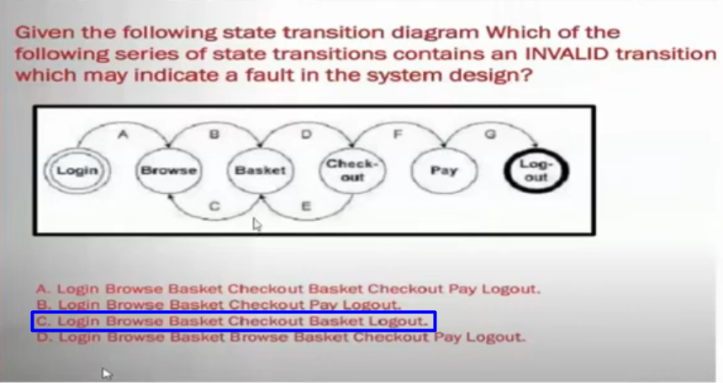

Q2
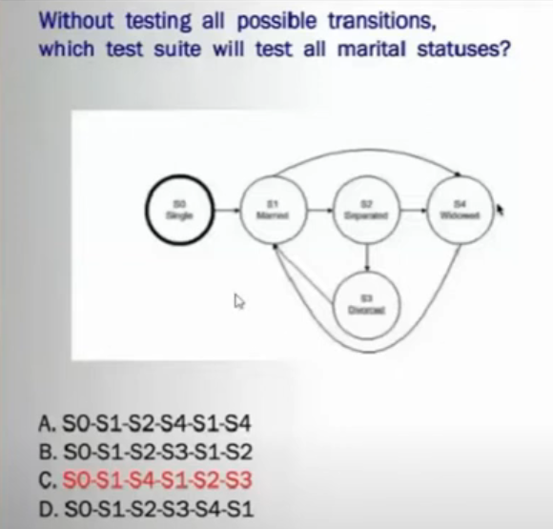

Q2 - Answer
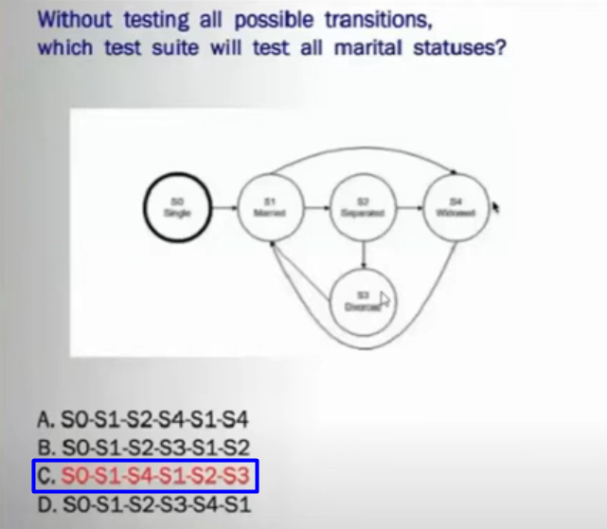

Q3
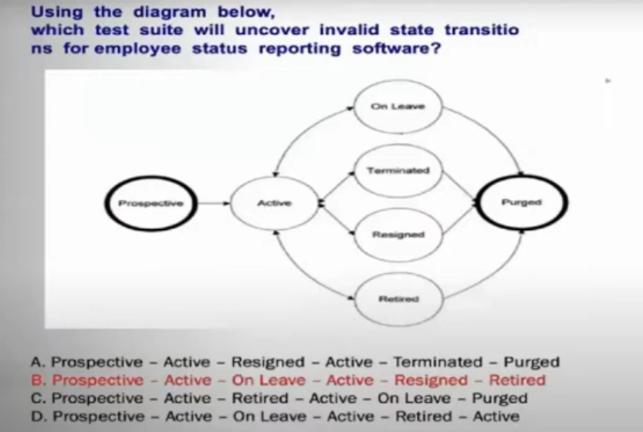

Q3 - Answer
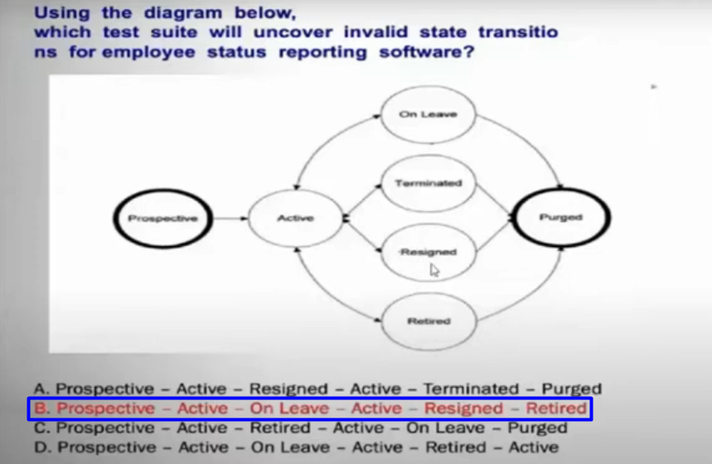

Q4
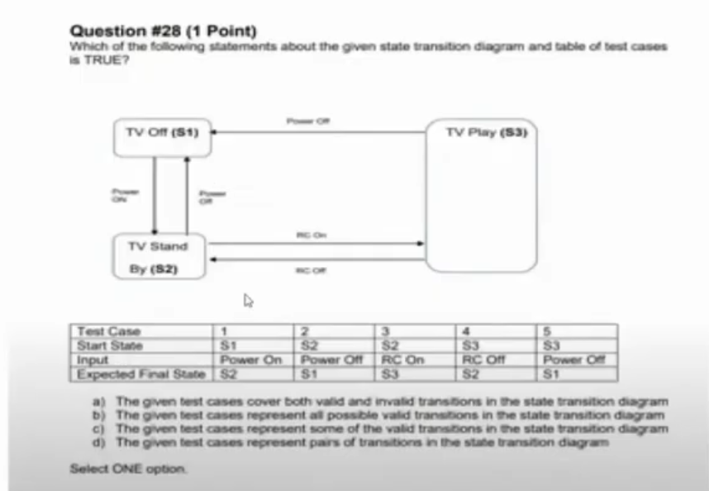

Q4 - Answer
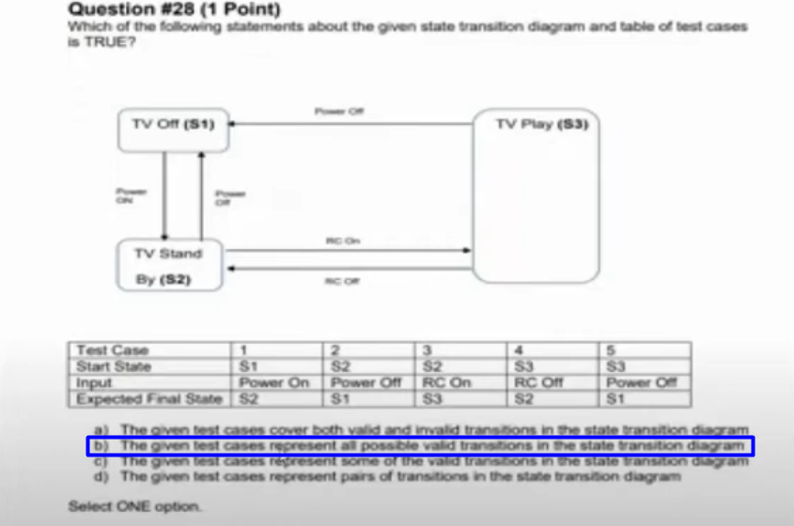

Q5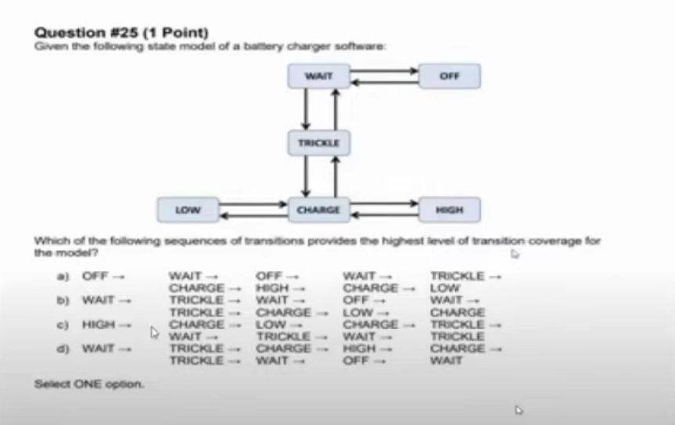
Q6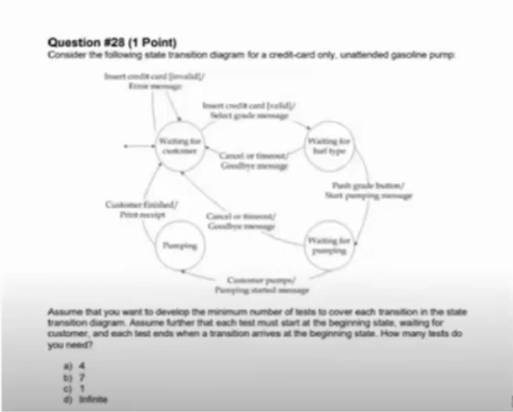
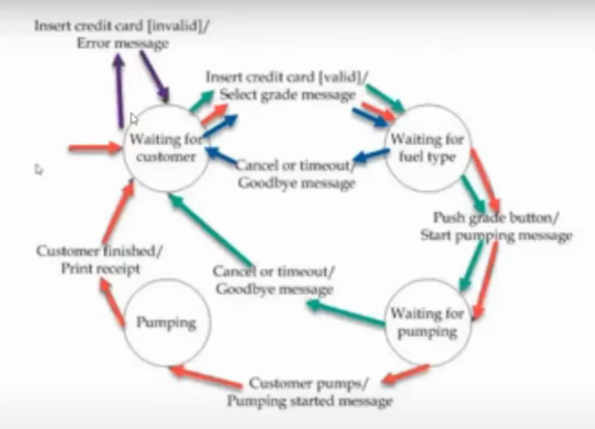

Details part 2
Chapter 4 part 2 state _ Decision - start at 36:14
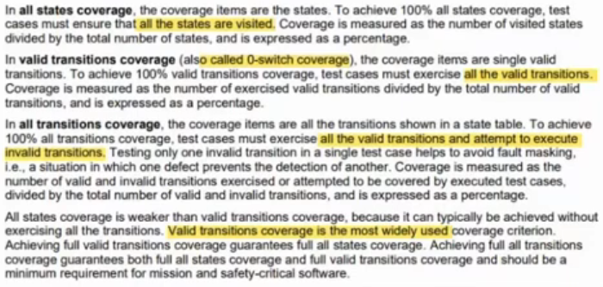

2.4-Decision Table Testing

Slide
Chapter 4 part 2 state _ Decision - start at 46:59
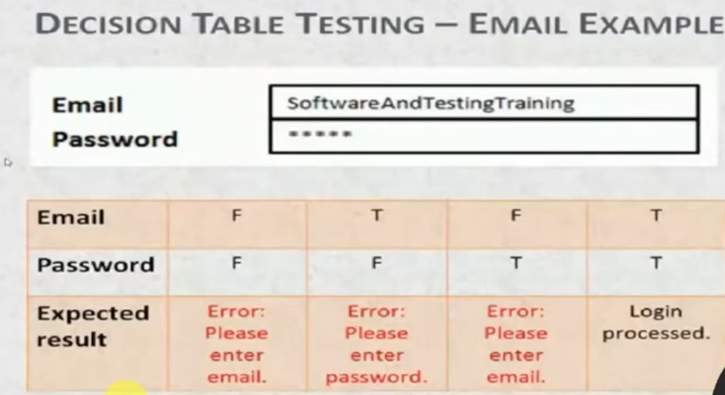
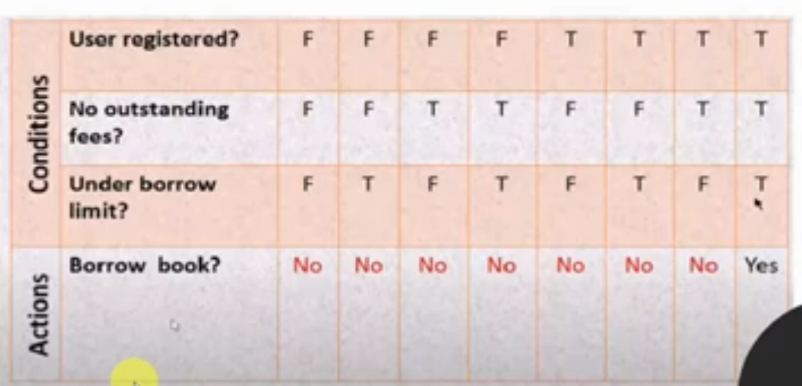
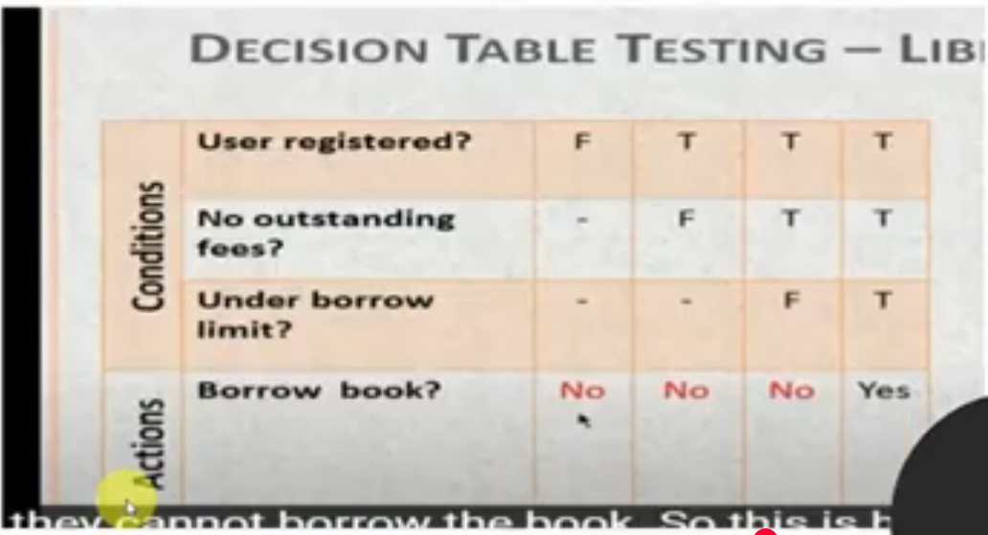

Questions
Chapter 4 part 2 state _ Decision - start at 58:09

Q1
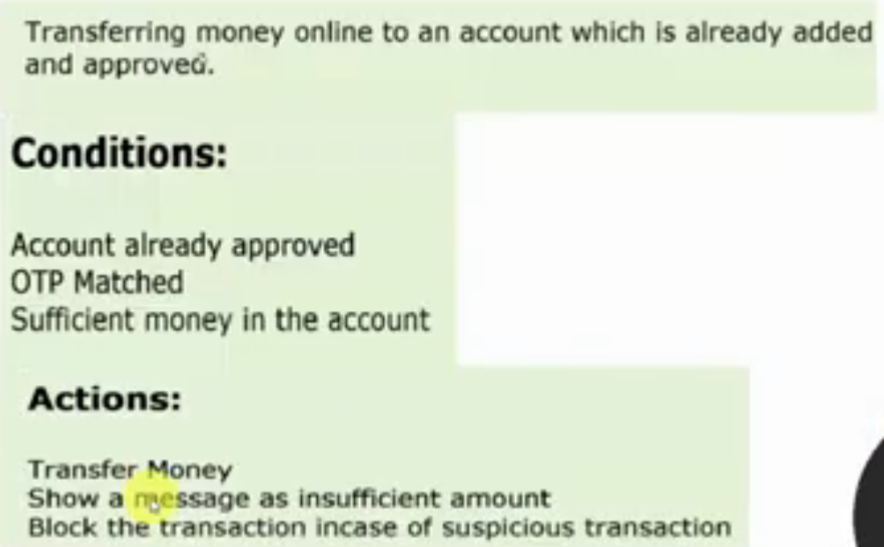
Q1 - Answer
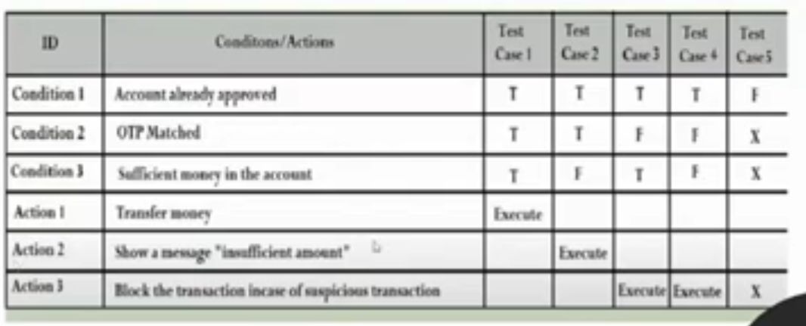

Q2
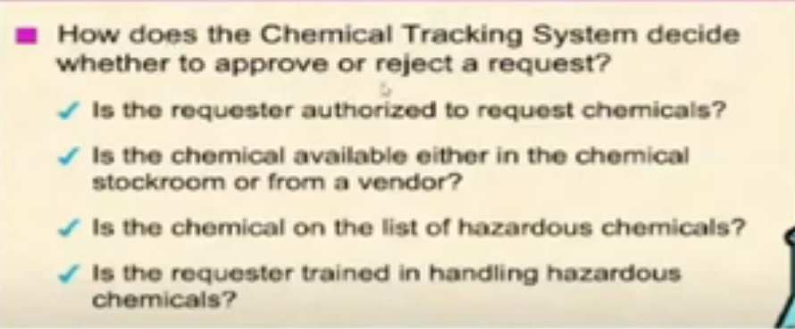
Q2 - Answer
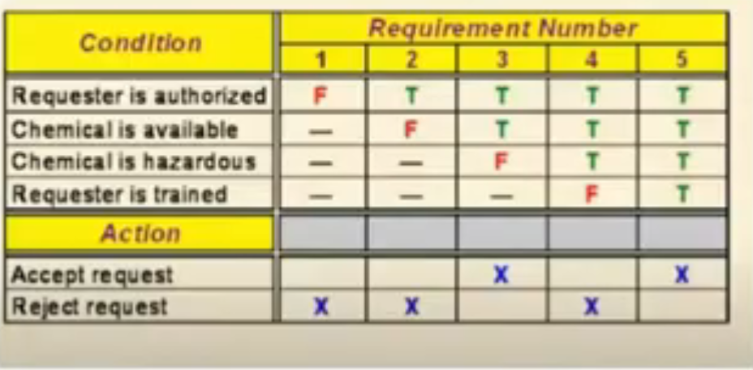

Q3
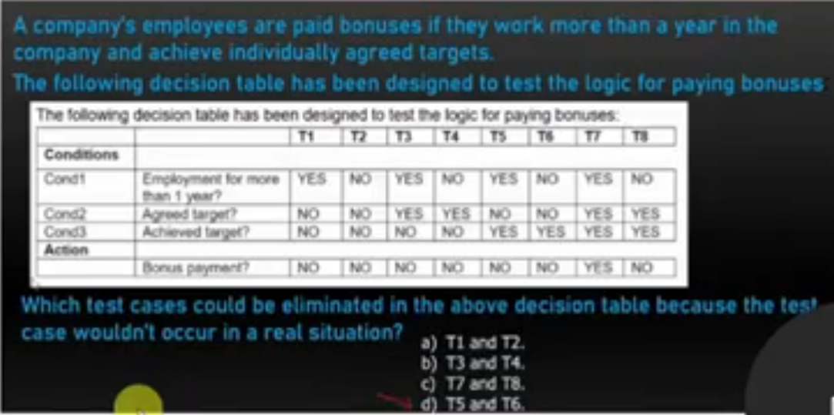
Q3 - Answer
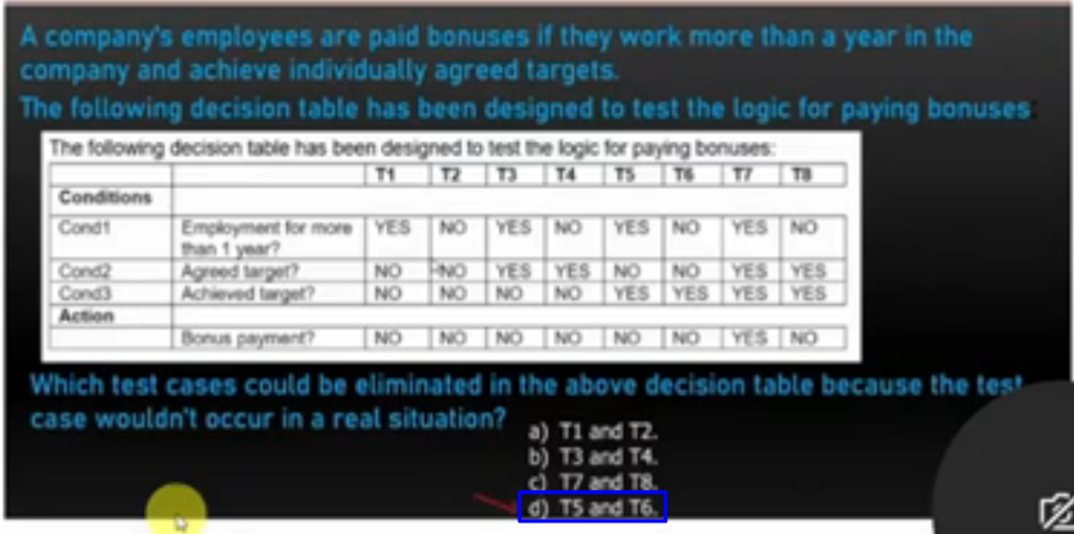

Details
Chapter 4 part 2 state _ Decision - start at 1:10:49
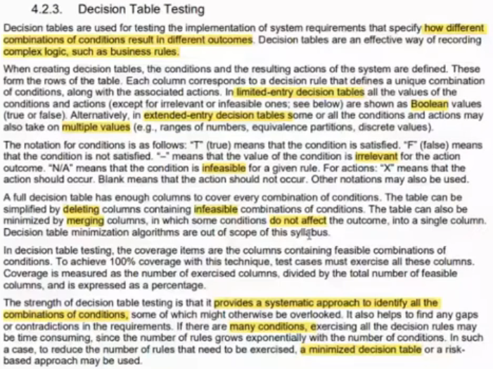

3.White box testing

Slide
Chapter 4 part 3 (white box) - start at 17:27
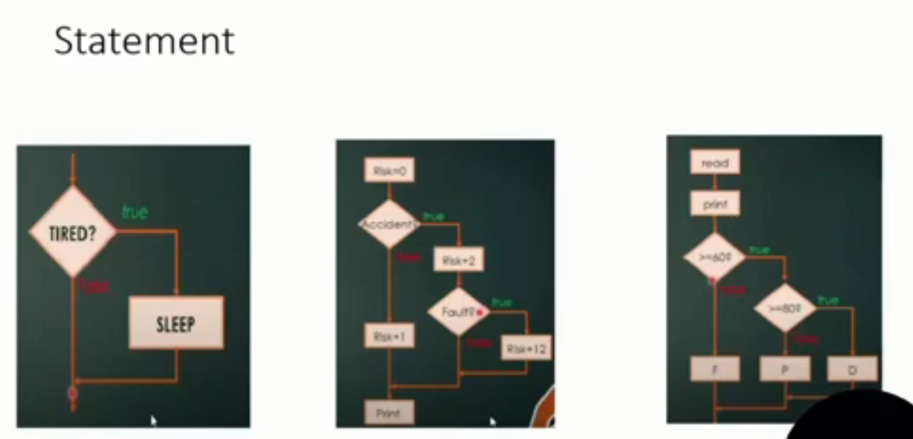
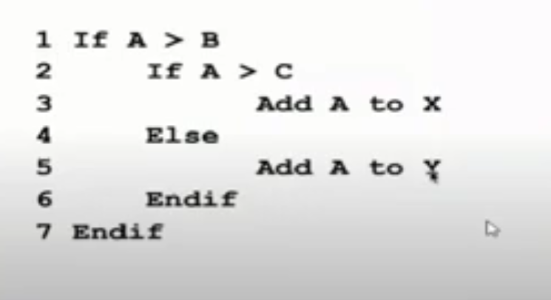
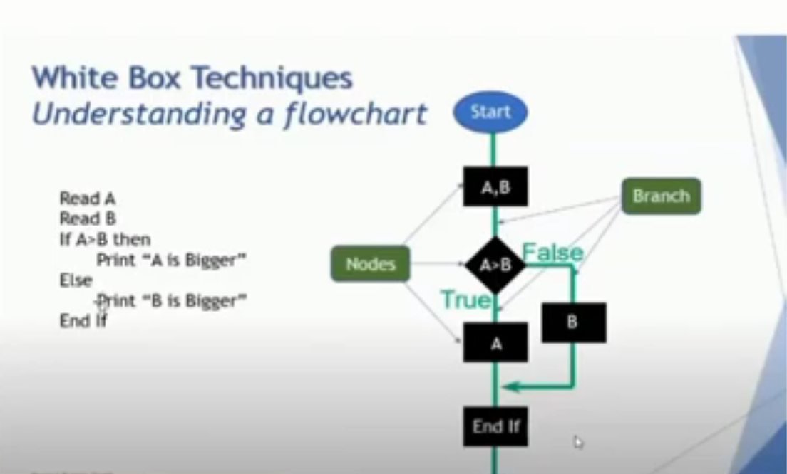
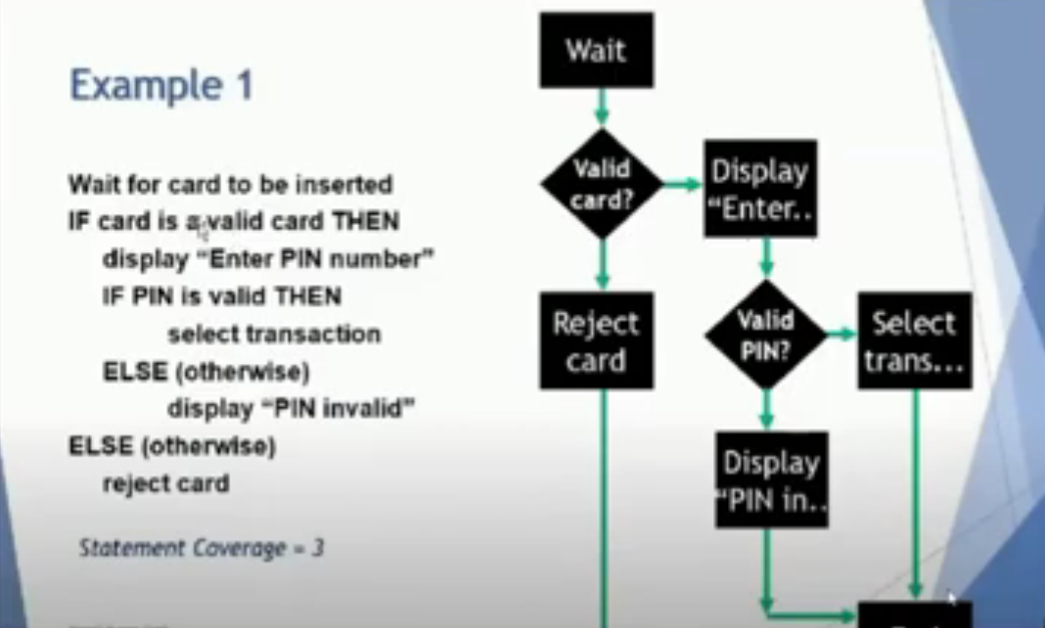
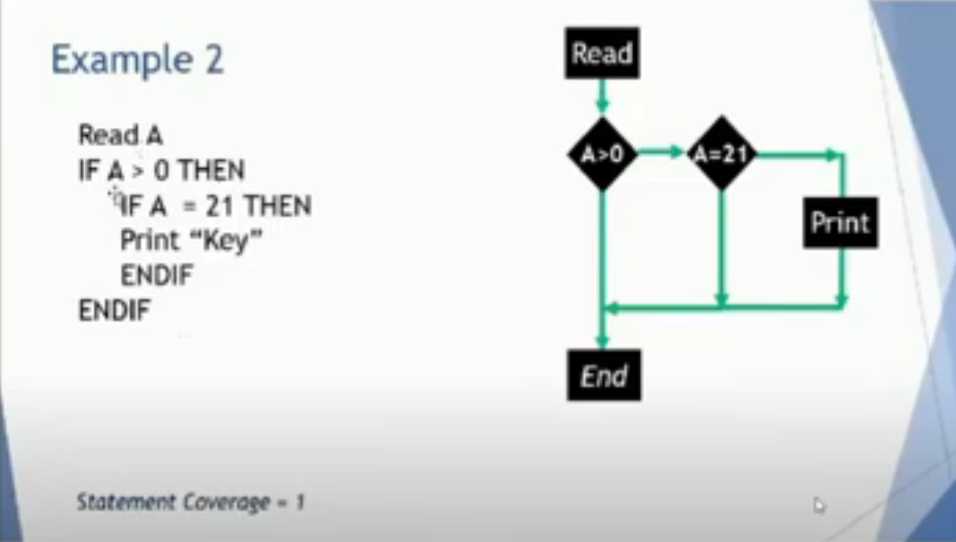
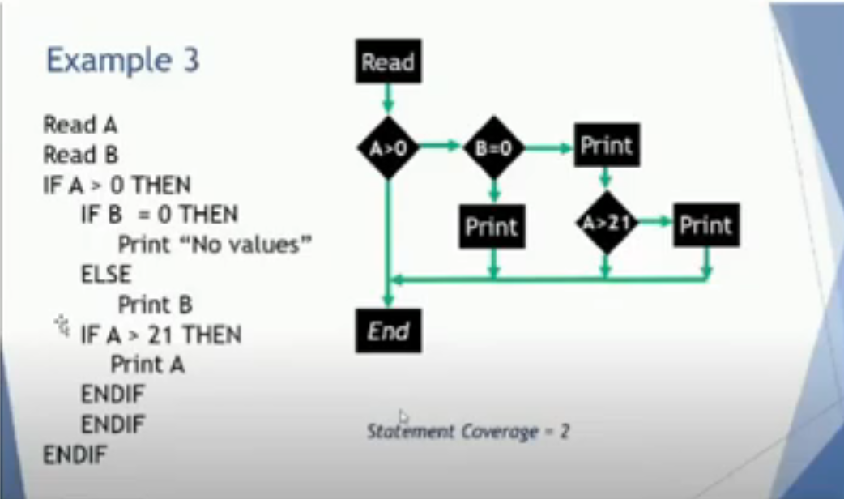
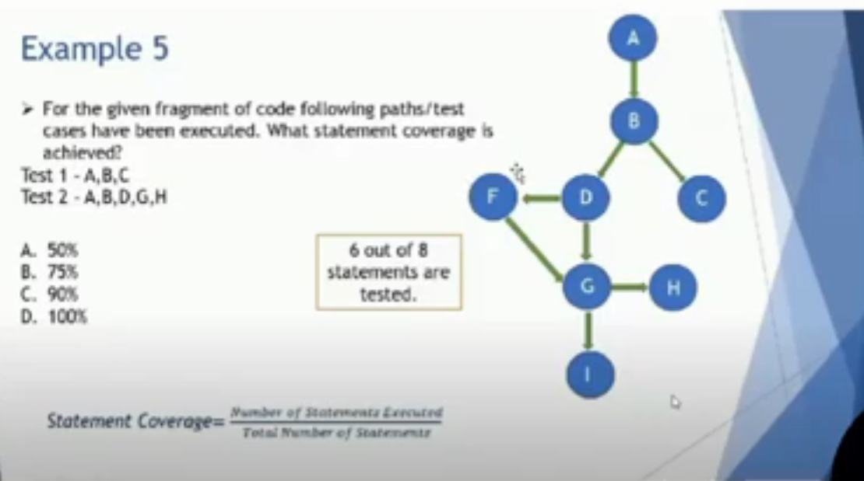

Questions
Chapter 4 part 3 (white box) - start at 57:30
Q1
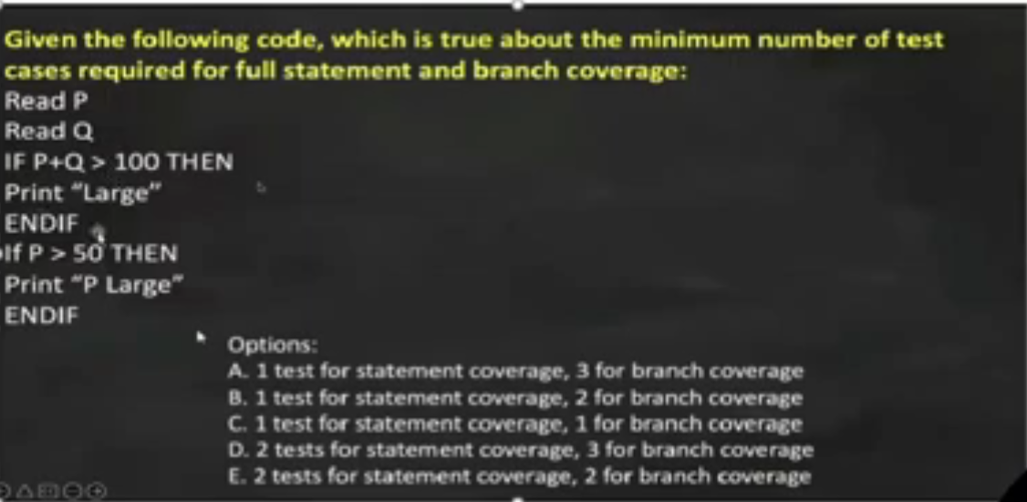
Q1 - Answer

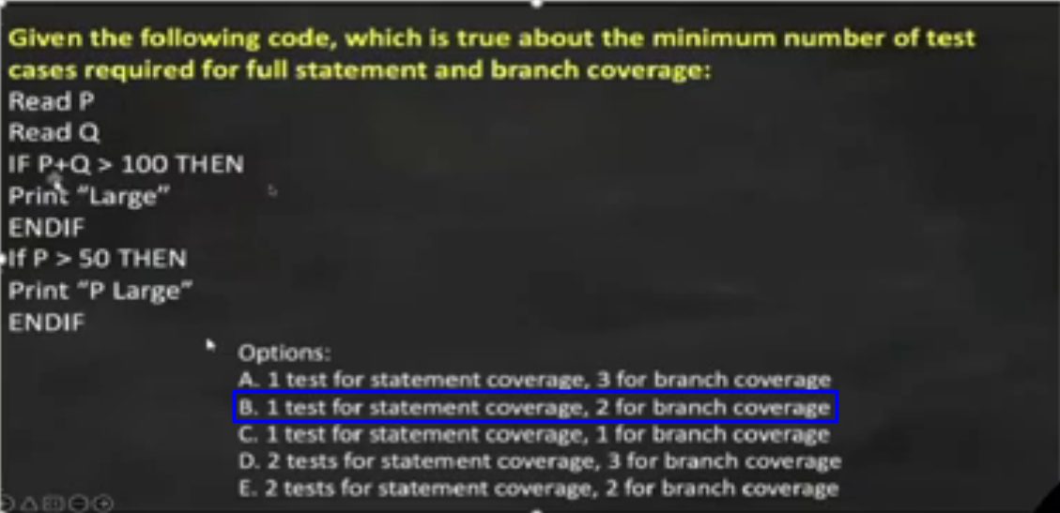
Q2
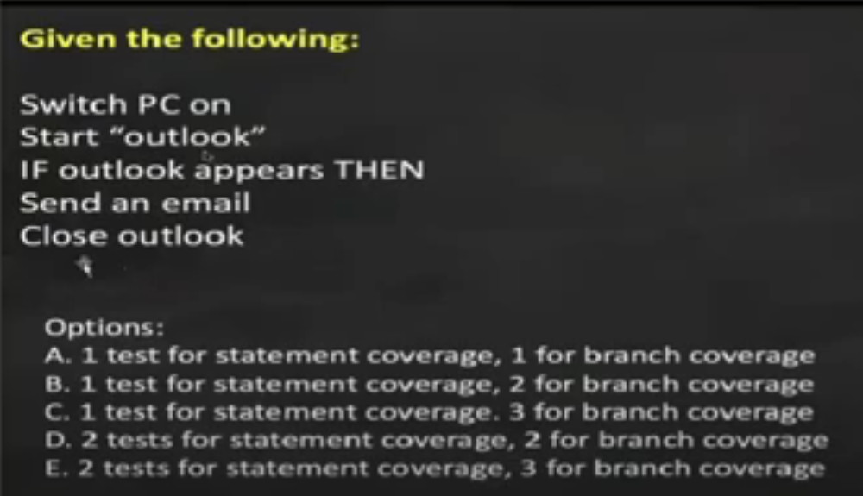
Q2 - Answer

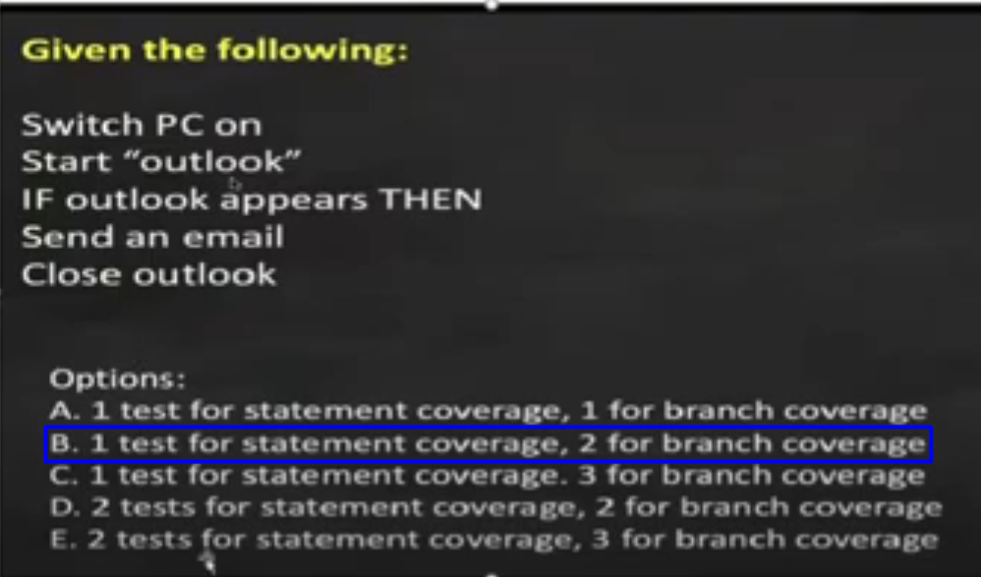
Q3
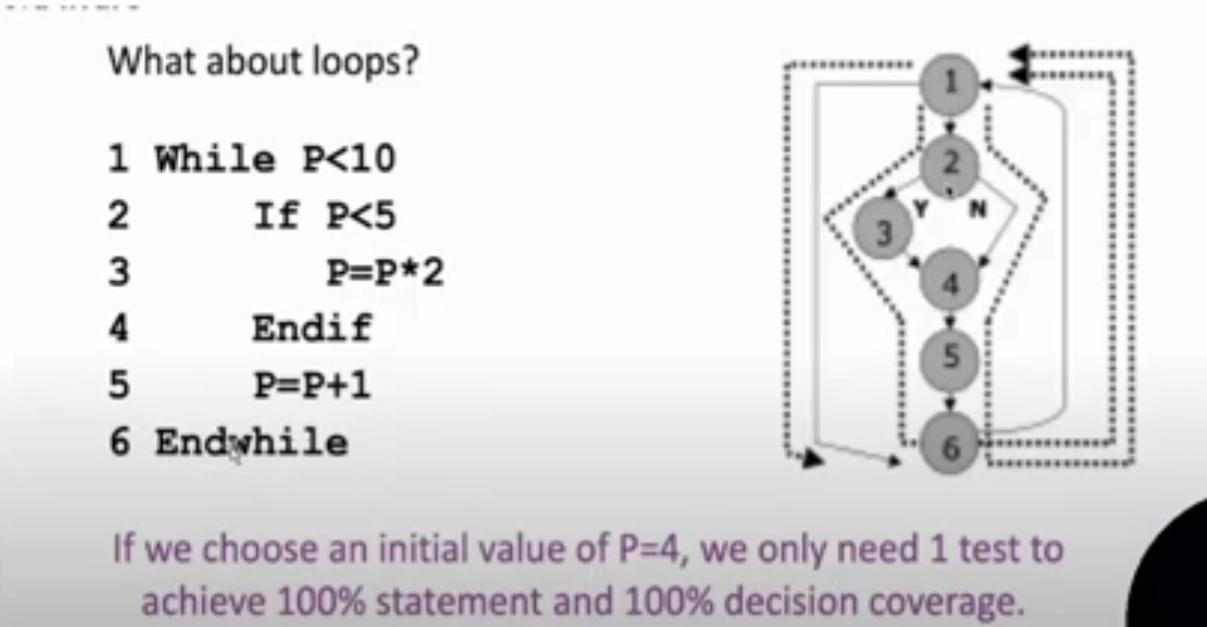

Q4
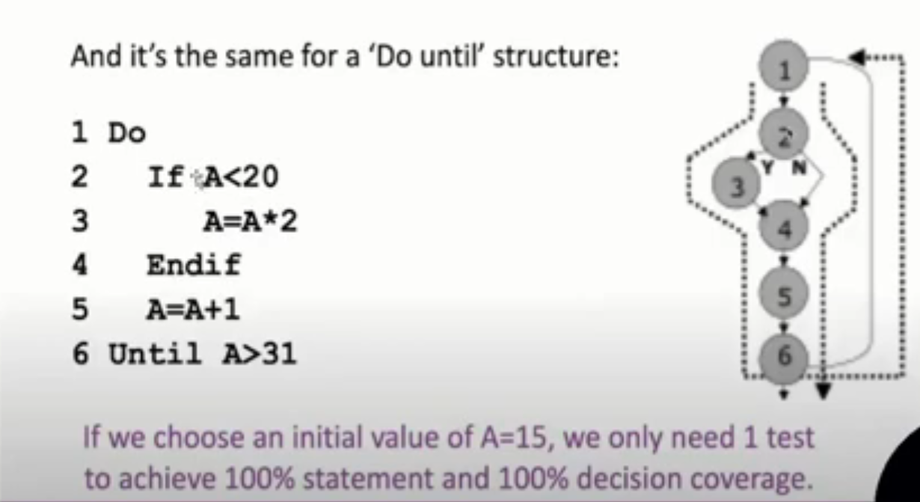

Details
Chapter 4 part 3 (white box) - start at 1:05:53
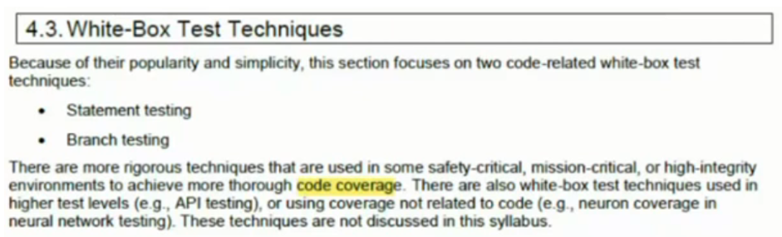

3.1-Statement Testing and Statement Coverage
Chapter 4 part 3 (white box) - start at 1:06:14
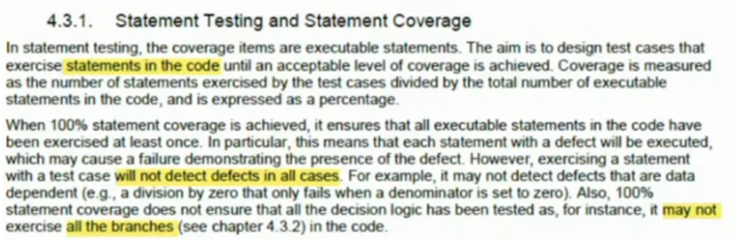

3.2-Branch Testing and Branch Coverage
Chapter 4 part 3 (white box) - start at 1:06:37
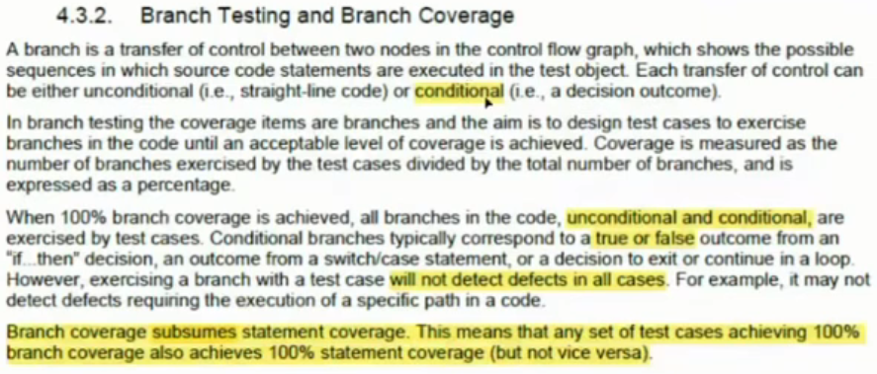

3.3-The Value of White-box Testing
Chapter 4 part 3 (white box) - start at 1:08:18
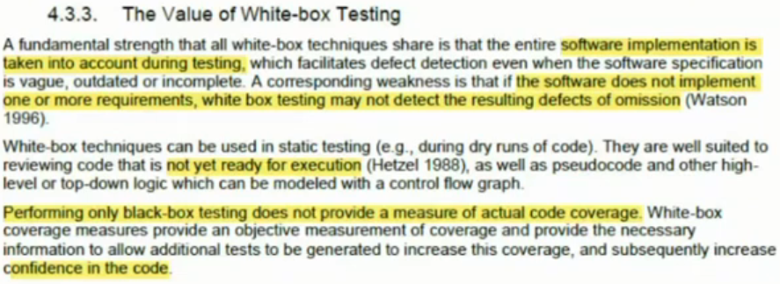

4-Experience-based Test Techniques uses
Chapter 4 part 3 (white box) - start at 1:09:48
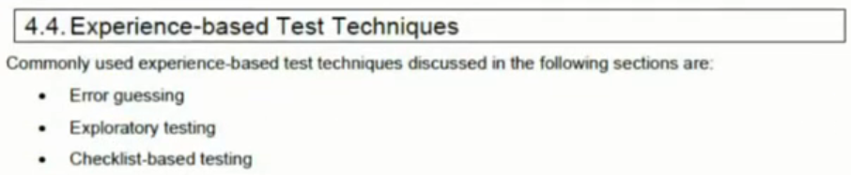

4.1-Error Guessing
Chapter 4 part 3 (white box) - start at 1:10:58
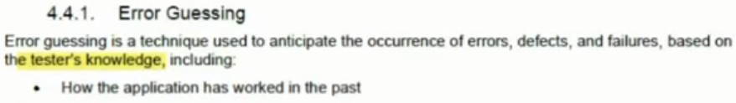
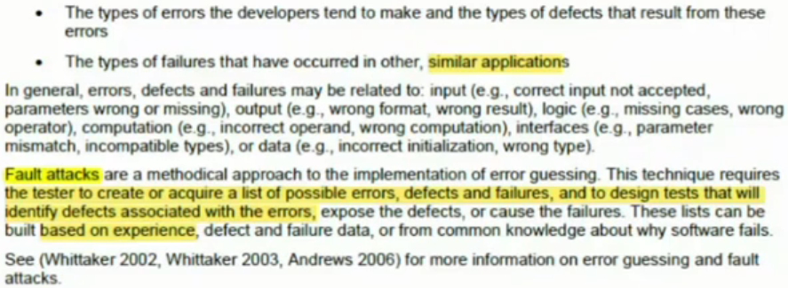

4.2-Exploratory Testing
Chapter 4 part 3 (white box) - start at 1:14:55
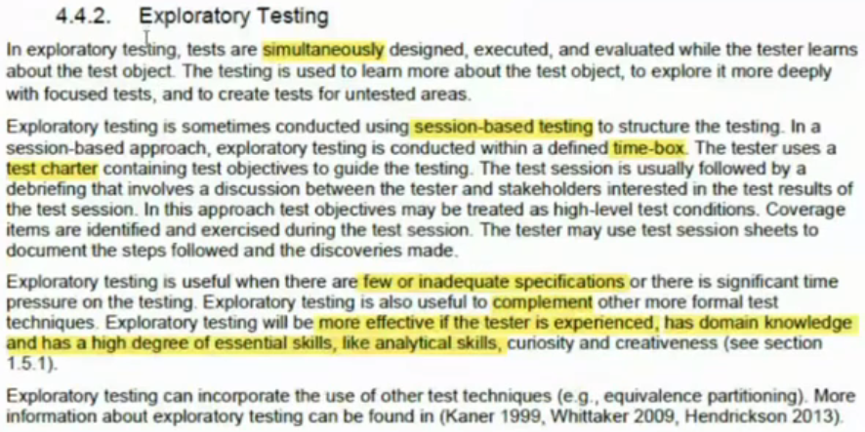

4.3-Checklist-Based Testing
Chapter 4 part 3 (white box) - start at 1:18:43
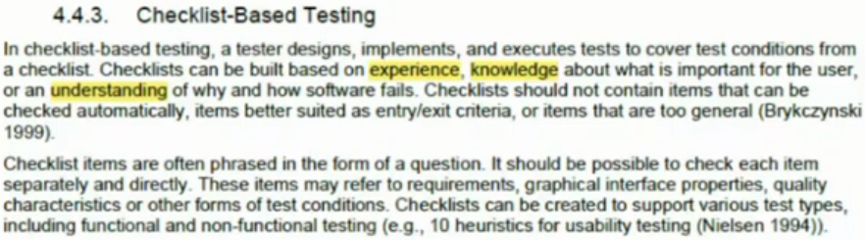
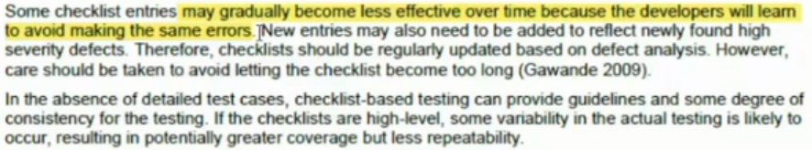

5-Collaboration-based Test Approaches
Chapter 4 part 3 (white box) - start at 1:20:39
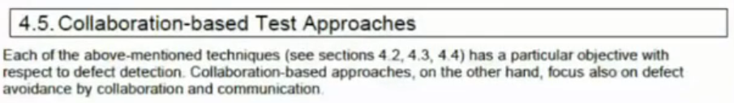

5.1-Collaborative user Story Writing
Chapter 4 part 3 (white box) - start at 1:20:39
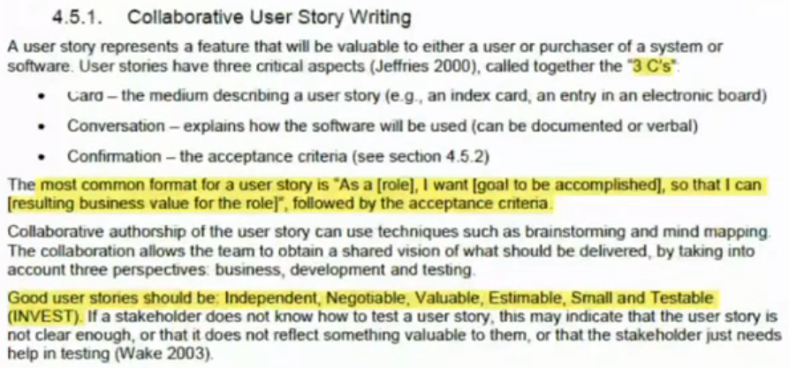

5.2-Acceptance Criteria
Chapter 4 part 3 (white box) - start at 1:25:40
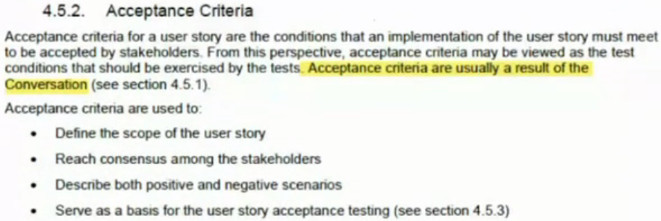
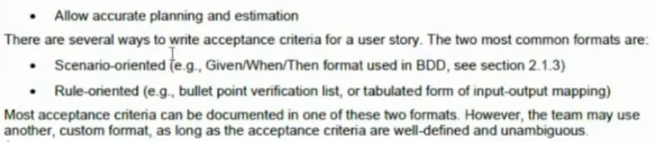

5.3-Acceptance Test-driven Development (ATDD)
Chapter 4 part 3 (white box) - start at 1:29:33
